GROUNDBREAKING MSR:
SCIENCE REQUIREMENTS AND COST ESTIMATES FOR A FIRST MARS SURFACE-SAMPLE RETURN MISSION

Final Report
of the
Mars Sample Return Science Steering Group
Glenn MacPherson, Chair

October 1, 2002

(For correspondence, please contact glenn@volcano.si.edu, 202-357-2260, or David.Beaty@jpl.nasa.gov, 818-354-7968)

This document is an abridged version of the original Oct. 1, 2002 report. The original report includes cost information which is potentially competition-sensitive, and which has been deleted. This report has been approved for public release by JPL Document Review Services (reference number CL#04-0549), and may be freely circulated. Suggested citation:

MacPherson, Glenn J. (Chair), and the MSR Science Steering Group (2002), Groundbreaking MSR: Science requirements and cost estimates for a first Mars surface sample return mission. Unpublished white paper, http://mepag.jpl.nasa.gov/reports/index.html.

TABLE OF CONTENTS

I. EXECUTIVE SUMMARY 3
II. INTRODUCTION 4
III. BACKGROUND 5
IV. PROCESS 6
V. PATHWAYS TO A GROUND-BREAKING MARS SURFACE-SAMPLE RETURN
A. Revised Science Requirements for the First Mission 8

B. Mars 2009 MSL Connections to Groundbreaking MSR 14

C. Planetary Protection and Sample Sterilization 16

VI. RESULTS OF THE INDUSTRY STUDIES FOR GROUNDBREAKING MSR:
COST AND RISK ANALYSIS 19

VII. SUMMARY 26

REFERENCES 27

APPENDICES
Appendix A: MSR SSG Members 29
Appendix B: Summary of original industry studies
for a MSR mission with MER-class mobility and science package 31
Appendix C: The First Returned Mars Samples:
Science Opportunities; JPL Publication 01-7 33
Appendix D: The Probable Science Return from
an MSR Mission with No Mobility (internal SSG report) 43
Appendix E: Industry reports for Groundbreaking MSR, as
presented to the MSR SSG on June 23-24, 2002 48

GROUNDBREAKING MARS SURFACE-SAMPLE RETURN:
SCIENCE REQUIREMENTS AND COST ESTIMATES FOR A FIRST MISSION

Final Report of the Mars Sample Return Science Steering Group

- EXECUTIVE SUMMARY
The first surface-sample return mission from Mars, termed Groundbreaking Mars Surface-sample Return, should consist of a simple lander whose only tools are an extendable arm with very simple sampling devices (e.g. combination of scoop + sieve), and a context camera (in addition to the navigation camera). Given that the mission will visit a site that has been previously characterized as interesting by other landed or orbital missions, the samples collected (minimum of 500g of fines + rock fragments + atmosphere) will provide critical fundamental knowledge about the evolution of Mars’ crust and climate and thereby enable the selective targeting of more sophisticated sample return missions in the future. These successor missions will in turn be able to better address the question of whether indigenous life does or once did exist on Mars.
- INTRODUCTION: SURFACE-SAMPLE RETURN MISSIONS AND A BALANCED MARS EXPLORATION PROGRAM
The collection and delivery of samples from an extraterrestrial body to Earth for laboratory analysis is the cornerstone for understanding that body’s formation and evolution. No robotic instruments can begin to provide the precise analytical measurements that can be obtained using laboratory instruments unconstrained by weight or volume or power limitations, under the most carefully controlled analytical conditions with samples that are ideally prepared for each type of analytical method, and subject to complete flexibility and repetition as the analytical results require. Detailed and precise understanding of crustal evolution with time, determining unambiguously the existence and nature of minute amounts of prebiotic or even biotic compounds, determining the timing and nature of any wholesale planetary differentiation, understanding the nature and formation of any regolith, determining the nature and abundance of volatiles, and deciphering the evolution of any atmosphere, are only possible through laboratory analysis of samples. Conversely, such results are most meaningful when understood in the context of global and regional data sets than can only be provided by extensive orbital and in situ landed missions. This has been vividly demonstrated by experience from exploration of Earth’s moon. The detailed knowledge of lunar rocks and fines that was obtained by laboratory analysis of the Apollo and Luna materials is taking on new meaning in light of the global chemistry data sets provided by the Clementine and Lunar Prospector missions. An ideal balanced program for exploring any rocky or even icy body in our solar system will consist of a judicious and cost effective combination of orbital, landed in situ, and surface-sample return missions. CAPTEM (The Curation and Analysis Planning Team for Extraterrestrial Materials) has used the lunar analogy to propose just such a balanced program for the exploration of Mars (CAPTEM, 2000).
As was the case for the Moon, the very first samples returned from the surface of Mars will provide such a monumental leap in knowledge over what has been gleaned remotely that such a “groundbreaking” mission not only can, but also arguably should, be very simple in its design and goals. Indeed, the recently-released NRC Decadal Survey for Solar System Exploration (National Research Council, 2002b) considers a first Mars surface-sample return mission to be so important that the report ranked it as the highest priority for a large (>$650 m) Mars mission in the next decade. The NRC report also correctly emphasizes that studies of the martian (SNC) meteorites are no substitute for surface sample return: the meteorites are a biased sampling of Mars, having no context, that include only impact-resistant igneous rocks of limited diversity (e.g., no “andesite”). Most importantly, they do not sample either regolith or sedimentary rocks that are of such vital importance to understanding Mars past climate and habitability.
The results of a first surface-sample return mission will greatly influence the planning of additional in situ and sample return missions. A useful analogy is geologic fieldwork. During a first field season in a new area on Earth, a geologist identifies and maps field-recognizably distinct units and then brings back samples of those units at the end of the season in order to understand exactly what those units are made of. The second and subsequent field seasons proceed in a more systematic fashion because the nature of the units is known and specific hypotheses can be tested in the field. By the end of approximately 2011, we will have a wealth of high-resolution imaging and global chemical and mineralogical data for the surface of Mars but we still will not really understand the temporal geologic, atmospheric, or hydrologic evolution of Mars. We will be fully ready to bring back samples of Mars’ rocks, regolith, and atmosphere for analyses in order to formulate informed hypotheses about martian processes and evolution. The main requirement for such a mission is careful site selection, chosen either to ensure sample diversity (e.g., an outwash plain, where the planet has already done the work of assembling a diverse collection of materials in a confined area) or else to maximize the potential for information about water, climate, and habitability.
The first surface-sample return mission will provide the insight necessary for more carefully targeted subsequent missions such as those that will specifically look for evidence of ancient – or even extant – martian life. Our global theories about Mars will certainly be greatly revised in response to the wealth of information provided by the first returned samples. Accordingly, subsequent sample return missions will require more precise landing capabilities, mobility, and sophisticated on-board science packages in order to go to and sample specific locations and even outcrops.
The first surface-sample return mission will also shed new light on orbital spectroscopic and in situ data, which can be firmly calibrated against the mineralogy and chemistry determined with great precision in terrestrial laboratories.
Finally, the samples from the by the first Mars surface-returned mission will provide critical data for estimating the hazards that may be present during eventual human missions to Mars (e.g. see the recent NRC report Safe on Mars; National Research Council, 2002c).
For all of the above reasons, the following report takes the position that a first sample return – the Groundbreaking Mission – not only can but should be very simple in its design and implementation, that it should be the first of several sample return missions that are increasingly sophisticated in their approach (sampling, on board science, targeting precision), and that this first surface-sample return mission can confidently be targeted on the basis of comprehensive global and regional imaging, chemical, mineralogical and physical data that is now or soon will be available for Mars.

BACKGROUND
Robotic sample return missions from Mars have been seriously contemplated since the late 1970s (the time of Viking), but the cost and complexity of such missions have resulted in continual postponement. Publication by McKay et al. (1996) of possible evidence for ancient martian microfossils caused greatly renewed interest in Mars sample return, but an accelerated (and overly ambitious) schedule of Mars exploration over the subsequent several years led to the loss of two spacecraft in 1999 and a complete rethinking of the Mars Exploration Program.
A new science advisory group was formed in 2000, called the Mars Exploration Payload Assessment Group (MEPAG), which involved over 100 representatives from diverse science disciplines related to Mars exploration. The first major product from this group was publication, in 2001, of Scientific Goals, Objectives, Investigations, and Priorities (MEPAG, 2001). This document lays out four well-established overarching goals for Mars exploration: Determine if life ever arose on Mars; Determine past and present climate on Mars; Determine the evolution of the surface and interior of Mars; and, Prepare for human exploration. Analysis of returned samples in terrestrial laboratories is highlighted in the report as an essential step to achieving many of the detailed objectives of all four goals.
NASA contracted with four industry groups (Ball Aerospace, Boeing, Lockheed-Martin, and TRW) in 2000 to independently design and estimate the costs for a Mars sample return mission, with a nominal launch date of 2011. The reports were completed in 2001 and delivered to NASA. Although differing in details, all of the original mission designs include a rover with extensive on-board science instrument packages (those original full reports are not included here; however, see Appendix B, tables B-1 through B-3 for science requirements and summaries of the original mission concepts). Most of the designs mitigate mission risk by some level of redundancy of landers, launches, or both. As proposed, cost estimates for the original industry designs approach $3 billion in real year dollars. When normalized (by JPL) to single-launch/single-lander configurations, the industry designs have estimated costs in the range $1.3 billion to $2.0 billion (‘02 dollars; see Appendix B, table B-4).
Because of revised US Government budget priorities following 9/11/2001, NASA was asked to re-examine its own priorities regarding missions. In the case of the Mars Exploration Program, the high proposed cost of sample return became especially problematic. NASA convened three special science “steering groups” in early 2002 to study: (1) a discovery-driven set of alternative pathways for exploring Mars during the period 2010-2020; (2) possible revisions to the science requirements under which the 2001 industry sample return mission studies had been made, with the goal of simplifying them in order to reduce cost yet still achieve important science goals; and (3) specific astrobiology science goals in the Mars Exploration Program. These three steering groups are designated as subcommittees of the MEPAG.
Dr. James Garvin, Mars Exploration Program Scientist, chartered the Mars Sample Return Science Steering Group (MSR SSG; #2 above) as follows:
In light of new information on the implementation of Mars Sample Return and in response to NASA's FY'03 budget, a Science Steering Group for MSR Studies has been convened. This group will support NASA's formulation of a discovery-driven Mars program for the second decade of exploration. The MSR SSG, together with JPL and industry, will focus on identifying affordable MSR missions that address the high priority science goals for Mars.

PROCESS
The MSR SSG met for the first time on February 19, 2002 in Scottsdale AZ. Subsequent teleconferences were held on April 18, May 2, May 16, May 30, and August 29. The full committee met again on June 23-24 in Arcadia CA. A draft report was turned in to NASA on July 12, 2002, and a preliminary presentation of findings was made to the Solar System Exploration Subcommittee (SSES) of the Space Science Advisory Committee (SScAC) on July 17, at NASA Headquarters. A revised report was presented to, discussed, and approved by the full MEPAG at its meeting on September 5-6, 2002 in Pasadena CA. Comments received at that meeting have been incorporated into this final report.
At its first full meeting in Scottsdale AZ in February 2002, the SSG heard summary presentations by the four industry groups on their earlier, mobile mission designs and cost estimates. As a result of these presentations, the committee realized that four factors were primarily responsible for a high estimated cost of “unconstrained” MSR. First are some of the science requirements themselves, especially the mandate for mobility (rover) and an extensive on-board science package. A second factor is the large degree of technology development required to be ready for MSR, such as precision landing, hazard avoidance, and the Mars ascent vehicle (MAV). Third, because all of the proposed mission concepts require successful completion of a long serial string of difficult events, the primary means of ensuring mission success was to add redundancy for the most risky events, e.g multiple landers/MAVs. Finally, there are stringent planetary protection requirements concerning both forward-contamination of Mars by terrestrial biota and back-contamination of Earth by putative martian organisms. Of the four, the science requirements are most clearly within the committee’s charge to address and as a consequence occupied most of its time during the period 02/2002 to 06/2002. However, such clear and unanimous concerns and recommendations regarding the other three were made by the industry groups, independent reviewers, and JPL engineers that this report addresses them as well, in the form of “findings” that we hope NASA will take very seriously.
Our first step, at the February meeting in Scottsdale, was to re-examine the science requirements that guided the industry teams in developing their original mission concepts for MSR in 2001. In particular, the SSG tried to determine whether all of the existing science requirements were appropriate for a first surface-sample return mission and whether removing any would significantly reduce cost without seriously impacting the expected science return. Two such science requirements were identified as having the greatest cost leverage: the need for surface mobility to achieve sample diversity, and the need for a highly capable on-board science package to identify and carefully select samples of the highest scientific interest.
As detailed in the following section, the committee at that first meeting recommended a revised set of science requirements and, together with JPL, asked the four industry teams to redesign their MSR concepts under the new guidelines. In addition, JPL took the further step of relaxing all other requirements such as specific risk abatement. The overriding MSR SSG goal in this exercise was to learn the answer to a question that had never before been asked: What is the real cost of a simple yet scientifically fully defensible surface-sample return mission from Mars?
The four industry teams were asked to complete their revised studies by mid-May, with the goal of making formal presentations to NASA/JPL and the MSR SSG in June. In addition, JPL revised its own MSR mission design and cost estimates (“Team X”). Finally, JPL contracted with SAIC Inc. and Aerospace Corporation to act as independent cost reviewers of the four industry and JPL studies. The industry, JPL, and independent review presentations to NASA and JPL (with some SSG members in attendance) were made on June 5-6 in Pasadena. Shorter summary presentations were made to the MSR SSG proper on June 24 in Arcadia.
In parallel with these revised costing efforts associated with the revised science requirements, the committee proceeded through a series of teleconferences to explore two other possible cost savings options: (1) how MSR might be directly linked with the 2009 Mars MSL mission, through shared technology or by having MSL accomplish some of the tasks necessary for MSR and thereby reduce requirements and costs for MSR; and (2) whether it might be scientifically reasonable to perform on-board sample sterilization prior to their arrival on Earth and thereby greatly reduce the expenses derived from planetary protection requirements.
V. PATHWAYS TO A GROUND-BREAKING MARS SURFACE-SAMPLE RETURN

A. Revised Science Requirements for the First Mission
The original mission requirements as delivered by JPL to the industry contractors in 2000 are listed in Table 1. These were the starting points for the SSG deliberations at the 2/2002 meeting.
The SSG learned that, of these, two of the dominant cost drivers are the requirement for mobility and the requirement for an extensive science instrument payload. Revising those requirements for the first MSR mission necessitated reconciling the differing objectives of the geologic and astrobiologic science communities. Whereas the Apollo experience demonstrated that regolith from almost anywhere on an ancient planetary surface will contain interesting lithologies that bear on a wide range of planetary evolution questions, the search for possible ancient microbial life demands more carefully targeted samples. The breakthrough to revising the original MSR science requirements came through two insights. First, a key step in deciding where to go for the more targeted astrobiology missions is to obtain basic representative samples of martian lithologies in order to begin to understand martian rock/hydrosphere and rock/atmosphere interactions – essential to understand martian climate and habitability. These first samples will almost certainly not contain information about past or present life, but they will tell us a great deal about the martian environment and its habitability. The second insight is that, through careful site selection for a first mission and a focus on regolith with entrained rock fragments, we will not need a rover, sophisticated on-board science instruments, or complex
Table 1. Original Level-1 Science Requirements for MSR Industry Studies
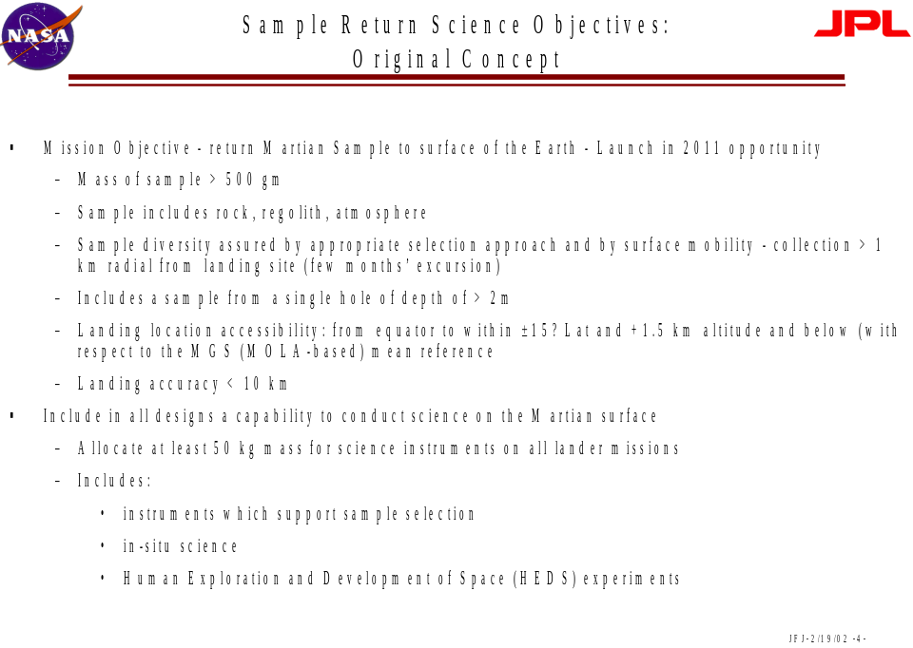

sampling tools in order to obtain important and diverse basic samples that will be informative in terms of martian physical and environmental evolution. In short, the first MSR mission will enable later, more targeted missions aimed at astrobiology. Because the existing body of knowledge of Mars materials is so small, all samples collected by the groundbreaking first surface-sample return mission will have a clear and disproportionate influence on planning for the targeting and instrumentation of subsequent MSR and in situ landed missions. These findings at the first SSG meeting led to a unanimous agreement that mobility (a rover), a sophisticated on-board science package beyond a simple context camera and an arm camera, and a need to be able to follow any particular precursor mission (e.g. Mars 2009 MSL) to any precise location on the surface of Mars should not be requirements for the first MSR. They were eliminated from the guidelines under which the revised industry mission designs and cost estimates were to be made. The only location requirement is that this first MSR be capable of going to a site that is selected based on information from any previous orbital or in situ missions to be scientifically interesting, and whose units are likely to be of sufficient extent that a landing precision approximately comparable to that of MSL (~ 10 km) will put the sample return mission in a position to sample them among nearby surface rocks. From the point of view of astrobiology, this translates to going to a site that is likely to contain significant evidence for the former presence of surface water and hence, past climates and habitability.
Finding: The first, Groundbreaking MSR mission must support the science objectives of Astrobiology, and it will do so by simply landing at a site shown by prior missions to contain information about Mars present and past climate and habitability. Mobility on the surface of Mars is not required. This mission should provide guidance for subsequent Mars sample return missions with increased probability of returning direct evidence of past or present life on Mars.

Finding: Landing precision comparable to that of Mars 2009 MSL [~ 10 km], and sufficient to assure landing safely, is adequate for the first mission if geologic units having lateral extents of >10-100’s of km are targeted. Analyses of returned samples can be generalized to the rest of each unit.

The original sample requirement for a minimum of 500 grams of sample that must include regolith and wind blown fines, rock fragments, and atmosphere is still considered essential and thus retained in the revised requirements. The outstanding science that can be accomplished with precisely this suite of martian samples has been described in detail by the Mars Sampling Advisory Group of the MEPAG (MEPAG, 2001b; attached as Appendix C) and further refined in our own studies as reported in Appendix D. Analyses of the samples in terrestrial laboratories will inherently result in discovery-driven Mars science, providing fundamental data addressing first order questions about the evolution of Mars crust and mantle, paleoclimate and the role of surface water, and the evolution of Mars’ atmosphere. Finally, the material properties derived from the laboratory studies will inform the planning for the eventual safe human exploration of Mars (e.g. National Research Council (2002c).

Finding: By collecting samples of fines (fine grained regolith and wind-blown dust), small regolith rock fragments, and atmosphere, the Groundbreaking MSR mission will achieve science goals fundamentally important to the Mars Exploration Program as defined by MEPAG.

Central to the discussion in that document (Appendix C) was that acquiring rocks, and not just fines, greatly increases the science value. Available evidence suggests that a suitable rock-rich sample suite can very likely be collected without requiring a rover or extensive on-board instrument suite. Images from the Viking and Pathfinder sites (e.g. Fig. 1) show that the martian surface is covered by four types of material: 1) in situ regolith, containing material with

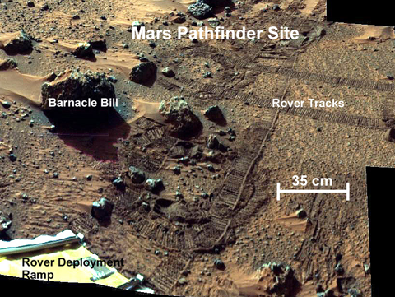

Figure 1. Photograph of the martian surface at the Pathfinder site, showing regolith (rocks + underlying fine-grained blue-gray material) and reddish wind-blown sand.

grain sizes ranging from fines (< several mm) to rocks that are meters or more in diameter; 2) dust (particles a few microns in diameter) that settled from the atmosphere; 3) wind-blown sand; and 4) materials developed in place by inferred weathering processes, forming rock weathering rinds, duricrust, and other products. Based on the image in Fig. 1, the Pathfinder site had many or all of these different materials within a very short distance of the spacecraft, and they would have been very accessible to the kind of arm + scoop suggested for Groundbreaking MSR. Most notably, there are many rocks in the area that are fresh-looking (blue-gray rather than red), in the <3cm size range, and suffered no apparent damage when the rover drove over them (they aren’t dirt clods). Based on likely crystal sizes in a variety of possible martian surface materials, the minimum rock size that is necessary for integrated mineralogic and geochemical work (especially isotopic age determinations) is in the range 0.5-10 mm (Table 2; see also Appendix D). Diversity considerations suggest sampling a larger number of rock fragments in the smaller end of the size range (0.5-1.0 mm), but relatively few rocks larger than about 2 cm (> ~12 g) as these would take up a disproportionate amount of mass. Evidence from Pathfinder suggests that a suitable abundance of rocks in these size ranges was available within 1-2 meters of the lander (Appendix D). Recognizing that the Pathfinder site may be unusually rich in small rocks, nevertheless:
Finding: Assuming that Groundbreaking MSR goes to a site similar to the Pathfinder site, and assuming an extendable arm with 2-meter reach and ~20 cm depth capacity, there is a high probability that the mission will succeed in achieving the stated sampling requirements.
The lander would likely include a context camera to provide panoramas for targeting and document the sampling area. Beyond this camera, however, the only sampling tools essential to achieve the required suite of samples are very simple. For example, a scoop and sieve working with a second camera on the end of an extendable and maneuverable arm, plus a gas-tight seal on the sample canister, would achieve mission goals. A sieve provides the ability to specifically acquire rock fragments in addition to the scoop-acquired fines. Other simple sampling devices might be considered (see below). The arm camera would provide close-up documentation of samples and the sampling processes, including imaging the insides of any trenches dug to characterize potential stratigraphy. As the regolith and rocks chips are already mixed on the martian surface, there is no requirement for individual sub-containers for each individual chip or samples (however, this might still be desirable, e.g. to separate wind-blown sand vs. regolith fines; much more investigation is required to determine the cost impact relative to benefits for Groundbreaking MSR). Moreover, because the samples will all be analyzed with maximum precision and flexibility in Earth laboratories, there again is no need on this first mission for on-board science analytical instrumentation.
The committee discussed at length three issues related to sampling instruments. The first is the possibility of retaining from the original requirements a regolith auger, in order to be able to obtain samples from as deep as perhaps one meter below the surface that might be informative regarding both the putative oxidant layer and also subsurface ice or water. The second possibility is to have a mini-rock corer on the end of the sampling arm, as an optional sampling device in order to ensure getting fresh rock samples from fragments that might have weathering rinds. The third possibility is to have a separate container for obtaining a dedicated atmosphere sample. There was insufficient time to determine the cost and engineering repercussions of these options, although the science gains are obvious. For example, the committee concluded that a mini-corer is a more sophisticated tool that might best be considered for missions subsequent to the first MSR. Yet, at a site with fewer small rocks than the Pathfinder site but abundant large rocks, a corer would help to ensure that actual rocks were collected as part of the sample suite. The committee decided NOT to make the auger, rock corer, or even a dedicated atmosphere container a requirement for Groundbreaking MSR, based solely on the unknown cost implications. NASA is urged to conduct more extensive studies to establish whether any of these options could in fact be incorporated on the groundbreaking MSR without major impact to cost or design. If the impact is large, these options should not be pursued for the Groundbreaking MSR but definitely considered for subsequent missions.
Finding: A simple context imager, an extendable robotic arm with arm-camera, simple sampling devices (for example, a scoop + sieve), and a sealable gas-tight sample canister, are sufficient on-board sensing and sampling systems for Groundbreaking MSR.

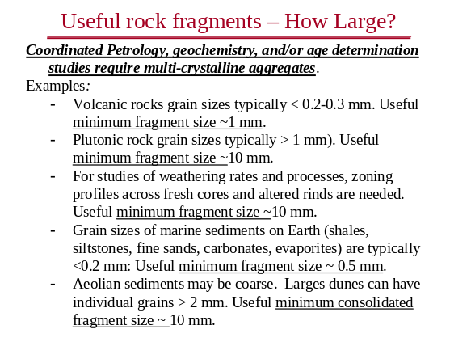
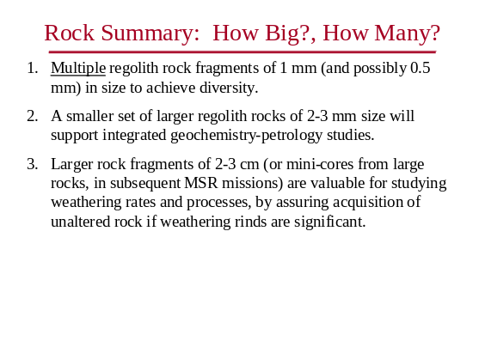

Table 2. Estimated requirements for rock fragments that will be most useful for a variety of science investigations. (Summarized from Appendix D)

The original landing location requirements would enable MSR to literally follow Mars MSL anywhere on the planet. This becomes problematic (thus, potentially, costly) at high latitudes and high elevations. Also, it is conceivable that in 2011 NASA might conclude that the site (s) visited by 2009 MSL is less interesting scientifically for sample return considerations than, say, one of the two MER ’03 sites. Finally there is the finding, described earlier, that the only requirement for Groundbreaking MSR should be the capability of visiting a general site or unit deemed to be interesting based on the results of any previous landed or orbital mission. In the revised requirements, therefore, the SSG eliminated the latitude and elevation requirements. Landing precision was required simply to be comparable to 2009 MSL, basically taking advantage of the technology developments required by the latter mission.
The resulting revised set of science requirements for a first, groundbreaking MSR mission are summarized in Table 3. These revised requirements formed the basis on which the four industry groups and JPL re-designed and re-costed a first Mars sample return mission. Table 4 compares the basic mission architectures of the original (“MER-class”) and new groundbreaking MSR missions.
Given the wealth of information about Mars that will be obtained by all of the orbital and in situ missions flown in the decade 2000-2009, there is no scientific reason that an intelligently-planned Groundbreaking MSR mission cannot be conducted soon after the MSL mission in 2009. The validity of the current Mars exploration strategy (orbiters, smart landers, sample return) cannot be verified until this final element is undertaken at least once. The NRC Decadal Survey for Solar System Exploration (National Research Council, 2002b) urged that Mars surface sample return be undertaken as soon as possible in the decade 2013-2023.
Finding: The first MSR should be flown at the earliest possible time following the completion of those missions now identified through 2009 MSL .

Table 3. Revised Science Requirements: Ground-Breaking Mars Sample Return
- 500 gm
- Samples of rock, regolith, atmosphere
- Land in a scientifically interesting area, as determined by previous in situ or orbital missions, with landing precision comparable to MSL (10 km)
- Context camera for sample collection, selection, and knowledge
- Samples held at temperatures below <50oC *
- Mission launch: 2013
- Mission duration < 5 years
- Option to break apart the mission, with elements launched from earth in separate launch opportunities (for example 2013, 2016)
- Planetary protection working goals (requirements t.b.d.)
- 10⁻² forward
- 10⁻⁶ backward

* This is not a requirement for active refrigeration, but rather, for insulation against heating during Earth atmosphere re-entry. Temperature maxima/minima should be recorded.

Table 4. Comparison of Sample Return Concept Designs:
Ground-Breaking vs. MER-Class

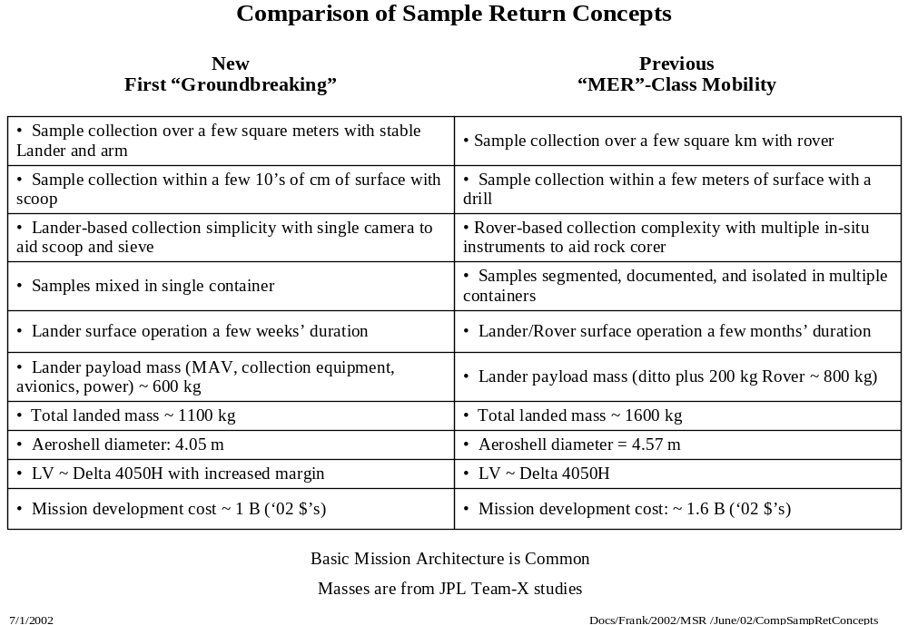

B. Mars 2009 MSL Connections to Groundbreaking MSR

The committee looked at various ways in which prospects for Groundbreaking MSR could be enhanced by linking it with the Mars MSL mission in 2009. Of particular interest are whether science tasks essential to Groundbreaking MSR might be accomplished by the prior mission, and how much technology and technology development can feed forward from MSL to MSR.
One of the first possibilities the SSG investigated was whether the 2009 Mars MSL mission could use its advanced sampling and science instrument package to identify samples of particular interest, and then either collect them and cache them all in one place for later retrieval by MSR, or else collect them and keep them for later rendezvous with MSR. While it is scientifically very tempting to use MSL functionality to enhance MSR, it quickly became evident to the SSG that the technological difficulties of attempting either option, plus the greatly increased complexity (and cost) to the 2009 MSL mission itself, rule out either possibility.

Finding: Attempting to use the 2009 Mars MSL mission to cache samples for or deliver them to the subsequent Groundbreaking MSR mission will likely result in unacceptable cost increases and risk, and daunting technological difficulties, for one or both missions.

However, there are a number of other surface science operations that can be conducted by 2009 MSL using its strawman instrument package, and which will greatly aid in the later surface operations of Groundbreaking MSR by allowing sample acquisition to proceed more quickly and effectively. It will be particularly important to learn how to recognize and collect key samples for return to Earth. These operations will be important regardless of whether MSR goes to the same general site as MSL. The proposed operations by 2009 MSL are appropriate and need not impose any additional costs, hardware, or technology development constraints on that mission.
Where 2009 MSL can be of greatest immediate benefit to Groundbreaking MSR is in shared technology and technology development. Especially if Groundbreaking MSR follows MSL by only 1-2 launch opportunities, the most cost effective and efficient course of action is to build the basic platform of both missions to a common design that can be adapted to their differing payloads (e.g. MSL rover vs. MSR Ascent Vehicle).

Mars 2009 MSL Science Feed-Forward TO MSR
One category of MSL surface operations that would benefit MSR even if MSR follows MSL by only one launch opportunity includes those that provide information that will test sampling and collection methods, and establish simple criteria to recognize interesting and diverse samples quickly. Groundbreaking MSR will need to be able to find the “right” samples quickly. Examples of such enabling 2009 MSL operations include:
- Do pebbles with different compositions have different morphologies? Can one reasonably identify differing basic rock types from a meter distance or more by external morphology and surface texture. Can 2009 MSL identify different grain morphologies and test to see if their composition correlates to their morphology?
- Are there other camera-viewable properties that can be used to infer composition? One could hope that the weathering rinds on grains retain some signature of the rock composition on which they are developed. Spectral data from 2009 MSL could be used to look for sample diversity and then correlate the observed spectra to basic rock composition. If a camera with some spectral discrimination is used for MSR, this prior experience will help select diverse samples.
- Measure geochemical gradients in the martian shallow subsurface, to support the sample collection strategy for MSR scientific investigations. In particular, use MSL to measure the oxidation gradient, which is needed to predict the depth where we could expect to begin to sample any reduced carbon.
- It would be valuable to know the physical state of the rocks and pebbles. Do pebbles have unaltered rock in their centers? Are most of the small objects on the surface just weathered “dirt clods”? This is important for “grab” sample strategies that will be using scoops, rakes, etc. What is the minimum rock size needed to have some amount of unaltered material in its interior? (It may be possible to get some data on this from MER).
Another category of 2009 MSL surface operations would benefit MSR only if MSR follows MSL by more than one launch opportunity. However, other missions prior to 2009 MSL (e.g. MER 2003) might address these objectives as well:
- Measure the lithologic diversity of the surface rocks in at least one geologic environment. For Groundbreaking MSR, this will give some idea of the number of pebbles needed to achieve a reasonable level of diversity. For subsequent and more capable MSR missions, this will provide information to estimate how much lateral mobility is needed by MSR to achieve lithologic diversity.
- Measure the size distribution in the martian regolith. This will help determine the sampling strategy needed to acquire a rock of minimum size in Groundbreaking MSR.
- Measure the concentration of volatile components in prospective samples (especially regolith). This is needed to design sample preservation strategies and hardware. Are there other characteristics of martian samples for which action is needed to assure preservation?

Mars 2009 MSL Technology And Design Feed-Forward TO Groundbreaking MSR
The following are examples of technology can be shared by MSL and Groundbreaking MSR, thus reducing the development costs and risks for MSR. If Groundbreaking MSR were scheduled only 1-2 launch opportunities after 2009 MSL, this engineering would need to be adopted with minimal modification.
- Lander platform design suitable for carrying either a rover or a MAV (or possibly, for a later MSR, both). A lander platform of this design will be consistent with: (1) a landed mass of 1500 kg; (2) a surface payload mass of approximately 750 kg and volume of 7 cubic meters compatible with a MAV and a rover; and (3) live platform surface operations through successful injection of the returned sample into Mars orbit.
- EDL system, including precision and robust landing, scalable to support a landed mass of 1500 kg and compatible with the lander platform design capabilities articulated in item #1 above. Such an EDL system will allow incorporation of an aeroshell with a diameter of at least 4.5 meters for consistency with the aforementioned capabilities.
- Sample transfer technology including selection, transport and subsequent verified transfer to and containment by the receiving element.
- All aspects of sample acquisition, including mobile collection of diverse samples of rock and soil, as well as robotic arms, scoops, rakes etc. or even a drill. Included within this is demonstration of robotic sample collection and caching systems (such as was partly already done for the original Athena payload), and sample acquisition autonomy.

C. Planetary Protection and Sample sterilization

Planetary protection requirements and science considerations mandate that not only must the outgoing MSR spacecraft be free to terrestrial organisms to a specified level (protection against forward contamination; see Table 2), but the returning spacecraft must break the chain of contact so that no martian materials will be carried outside of the sample container (protection against backward contamination). In the original industry presentations given at the 02/2002 meeting of the MSR SSG, the technology development to mitigate backward contamination was a significant driver of cost and complexity. Moreover, although the cost of building a sample receiving facility on Earth to contain potentially biohazardous materials was not included in the estimates of any of the industry teams, such cost is likely to be significant. These considerations raise the possibility of sterilizing the samples prior to their arrival back on Earth. The methods of sterilization considered were irradiation and either dry heat or heat in combination with some chemical agent.
Sterilization might plausibly be implemented at any phase in a sample return mission. On the surface of Mars the samples might be heated in a container on the rover, the lander, or the ascent vehicle. In space the samples could be heated in a container in the ascent vehicle or in the return vehicle. Following landing on Earth the samples, the container, or even the entire spacecraft might be heated in a receiving facility. Each option carries safety and scientific advantages and disadvantages.
Sterilization on Mars would have the advantage of occurring very early in the mission, allowing the maximum range of later options. Conversely, it imposes significant additional mass / power / volume constraints on the mission due to the necessary sterilization and verification hardware that must be included on the landed spacecraft. Also, it does not address “breaking the chain of contact”. Finally, venting of any released volatiles (from the sterilization cycle itself) to the Mars atmosphere results in complex pressure management design issues and the possibility of recontamination. Sterilization in space allows sterilization and verification hardware to remain on the orbiter and hence does not impact the lander itself. Also, it can better achieve “breaking the chain of contact”, and venting of released volatiles to space would minimize the possibility of recontamination. The disadvantage of sterilization in space is that the sterilization and verification hardware must remain operational in orbit.

Finally, sterilization of the samples after delivery to Earth frees the entire spacecraft from any additional constraints imposed by sterilization and verification hardware. Venting of released volatiles can be controlled. However, this option does not address “breaking the chain of contact” due to possible dust on the outer surface of the return vehicle.
Heat sterilization is the most effective, but from a MSR scientific point of view also the most controversial. To give some indication of the temperatures involved, consider the following:
- The highest temperature at which microbial growth has been documented is 113oC (Stetter, 1996), although the absolute limit remains to be determined.
- A report from the National Research Council (1998) states: “A theoretical 160oC upper limit on growth (at 1 atm pressure) is dictated by the thermal instability of macromolecules, membranes, and other cellular structures, but growth at temperatures even higher cannot be discounted when all environmental parameters (such as high pressure) are considered. Because the upper limit for growth will depend on high pressure, and the environments likely to be encountered in sample return missions will be at low rather than high pressure, the theoretical 160oC upper temperature limit for growth is reasonable.”
- Protocols for dry heat sterilization of medical instruments typically range from 140oC for 3 hours to 170oC for 1 hour (National Research Council, 2002).
- The NASA-certified dry heat sterilization of the Viking landers involved heating both spacecraft to 135oC for 24 hours prior to launch (National Research Council, 2002).
Unfortunately, heating to temperatures near the upper end of these ranges has significant effects on other properties of the samples, especially dehydration or other structural breakdown of possible martian minerals that would be important clues in “following the water”. As a reasonable limiting case, heating to 200oC would strongly affect the following (data from Gooding, 1990; Neal, 2000; Kotra et al., 1982; Golden et al., 1999; Biemann et al.,1977; Brinton et al., 2001): Carbonate phase transitions, salt mineral / water isotope exchange, water ice / vapor isotope exchange, capillary water mobilization, brine liquefaction, gas desorption, CO₂ ice evaporation, water ice transitions, salt mineral H₂O(+) loss, clay mineral H₂O(-) loss, remanent magnetism, zeolite dehydration (partial), clay / zeolite / water isotope exchange (partial), maghemite / hematite transition (partial), Al,Fe oxyhydroxide H₂O(+) loss (partial), clay mineral H₂O(+) loss (partial), partial noble gas loss; at least partial loss of volatile organics including saturated and polycyclic aromatic hydrocarbons, and at least partial racemization of amino acids. Effects on higher temperature rock components and properties would be minor, such as: rock morphology / density / porosity, soil particle size / morphology, petrography, non-volatile chemical composition, silicate and oxide mineralogy, many isotope ratios including those used for radiometric age determination.
Note that many of the most sensitive properties are those relating to water and organic compounds. Yet, the primary drivers behind the current Mars Exploration Program are to follow the water and search for signs of ancient or extant indigenous life of the surface of Mars. Thus, heat sterilization of the entire sample payload represents a fundamental philosophical disconnect with the entire program. The committee cannot rationalize destroying most or all evidence of the principal things we are going to Mars to seek.

Finding: Heat sterilization of Mars samples prior to Earth arrival is irreconcilable with the most important scientific goals of the Mars Exploration Program. This option should not be considered, regardless of possible cost savings.

Sterilization of the samples by irradiation (gamma) in space or on the surface of Mars is believed to be far less destructive of the sample properties than heat sterilization. However, understanding the efficiency of this process and the technical (and political) difficulties of implementing it are beyond both the expertise of the MSR SSG and the time frame of the committee’s operation. We note with interest that proposals do exist for in-space sterilization of Mars samples using radionuclides. These should be studied in detail, both for feasibility and for the effects on organic and inorganic materials similar to those expected from MSR. In particular, it must be shown that sterilization by irradiation would not also (like heat) irreparably destroy the scientific value of the samples with respect to Mars Exploration Program goals.

Finding: Sterilization of Mars samples by radionuclide irradiation may be a feasible path to cost savings for Groundbreaking MSR, but much more study is needed to establish the viability and effects on materials.

Although the nature and cost of a Mars Sample Receiving Facility (SRF) are outside of the purview of the MSR SSG, its potential high cost to the overall Mars Exploration Program negatively impacts the viability of Mars sample return itself. For example, one concept of the SRF involves a complex facility combining elements of both a clean room and a biohazard containment facility – something that has never been built – and containing a wealth of sophisticated scientific equipment. Yet a SRF in some form clearly is essential, not just for MSR but also other possible sample return missions of potential bio-interest. Owing to its importance, high cost, and technological difficulties, diverse options for a SRF must be studied in much more detail and a final concept arrived at in order for implementation to begin as soon as possible.

Finding: Diverse concepts for a Mars Sample Receiving Facility must be studied in great detail to arrive at a cost-effective final plan. This needs to begin soon, because of the large lead time that will be needed to plan and build and test such a facility.

VII. SUMMARY

The collaboration between the MSR SSG, Industry, and JPL has defined a first Mars Surface-sample return mission that is:

- Affordable
- Simple sample acquisition -- no surface mobility
- Short-duration surface operations
- In situ sensors limited to cameras

- Scientifically valuable
- Returns scientifically rich samples of regolith fines and rocks, wind blown fines, and atmosphere

- Supportive of broad program goals
- As defined by MEPAG, and consistent with the NRC Decadal survey

- Has broad science community support
- Approved by MEPAG

- Credible
- Multiple, independent organizations converged on similar mission architectures and costs

In order to maintain a low cost profile for Groundbreaking MSR, the Mars Program should:

- Prevent the science requirements from escalating
- Initiate as soon as possible an aggressive technology development program that focuses on key high-risk elements of MSR
- Design a program with a high degree of technological commonality among the upcoming series of Mars landers starting with 2009 MSL.

REFERENCES
Biemann, K., Oro, J., Toulmin, P., III, Orgel, L.E., Nier, A.O., Anderson, D.M., Simmonds, P.G., Flory, D., Diaz, A.V., Ruchsneck, D.R., Biller, J.E. and LaFleur, A.L. (1977) The search for organic substances and inorganic volatile compounds in the surface of Mars, Journal of Geophysical Research, 82, 4641-4658.
Brinton K. L. F., A. Belz, and G. D. McDonald (2001). Amino acid racemization on Mars. Abs. Pap. ACS 211, GEOC-172.
CAPTEM (Curation and Analysis Planning Team for Extraterrestrial Materials): Jolliff B. L., Keller L. P., MacPherson G. J.,. Neal C. R, Papanastassiou D. A., Ryder G., Shearer C. K. and Papike J. J. (2000) A balanced model for exploration of the terrestrial planets: Lessons from the lunar experience. Concepts and Approaches for Mars Exploration, July 18–20, 2000; Houston, Texas
Golden, D.C., Ming, D.W., Lauer, H.V., Jr., Morris, R.V., Galindo, C., and Boynton, W.V. (1999) Differential scanning calorimetry of hydrous minerals under Mars-like conditions: calibration studies for the Mars ’98 lander thermal and evolved gas analyzer (TEGA) (abstract). Lunar and Planetary Science Conference XXX, # 2027.
Gooding, J.L. (1990) Scientific Guidelines for Preservation of Samples Collected from Mars. NASA Technical Memorandum 4184, National Aeronautics and Space Administration, Washington, DC.
Kotra, R.K., Gibson, E.K., and Urbanic, M.A. (1982) Release of volatiles from possible martian analogs. Icarus, 51, 593-605.
McKay D.S. et al., Science 273, p. 924 (1996).
MEPAG (2001a) Scientific Goals, Objectives, Investigations, and Priorities. In: McCleese D., Greeley, R., and MacPherson G. (eds) Science Planning for Mars. Jet Propulsion Laboratory Publication 01-7 (53 pp)
MEPAG (2001b) The First Returned Mars Samples: Science Opportunities. In: McCleese D., Greeley, R., and MacPherson G. (eds) Science Planning for Mars. Jet Propulsion Laboratory Publication 01-7 (53 pp)
National Research Council (1997) Mars Sample Return: Issues and Recommendations. National Academy Press, Washington, DC.
National Research Council (1998) Evaluating the Biological Potential in Samples Returned from Planetary Satellites and Small Solar System Bodies. National Academy Press, Washington, DC.
National Research Council (2002a) The Quarantine and Certification of Martian Samples. National Academy Press, Washington, DC.
National Research Council (2002b) New Frontiers in the Solar System: An Integrated Exploration Strategy. [in press] National Academy Press, Washington, DC.
National Research Council (2002c) Safe on Mars. National Academy Press, Washington, DC.
51 pp.
Neal, C.R. (2000) Issues involved in a Martian sample return: preservation and the Curation and Analysis Planning Team for Extraterrestrial Materials (CAPTEM) position. Journal of Geophysical Research, 105, 22,487-22,506.
Stetter, K.O. (1996) Hyperthermophilic prokaryotes. FEMS Microbiological Review, 18, 89-288.

APPENDIX A. MSR SSG Members

MSR SSG Members

Carl Agee
Univ. New Mexico

Carl Allen
NASA Johnson Space Center

Ray Arvidson
Washington University

Jean-Pierre Bibring
Université Paris Sud

Daniel Britt
University of Tennessee

Jean-Louis Counil
CNES

Michael Duke
Colorado School of Mines

Jack Farmer
Arizona State University

Ronald Greeley
Arizona State University

Chris House
Penn State University

Laurie Leshin
Arizona State University

David Lindstrom
NASA Johnson Space Center

Glenn MacPherson
[MSR SSG Chair]
Smithsonian Institution

Steven Mojzsis
University of Colorado

Kenneth Nealson
USC

James J. Papike
Univ. New Mexico

Mark Saunders
NASA Langley Research Center

Roger Summons
MIT

Dawn Sumner
University of California, Davis

Jet Propulsion Laboratory

David Beaty

Frank Jordan

Richard Mattingly

Steve Matousek

Daniel McCleese

Dimitri Papanastassiou

Charles Whetsel

Richard Zurek

NASA Headquarters Officials

Orlando Figueroa

James Garvin

George Tahu

Appendix D.
Probable Science Return from an MSR mission with no mobility

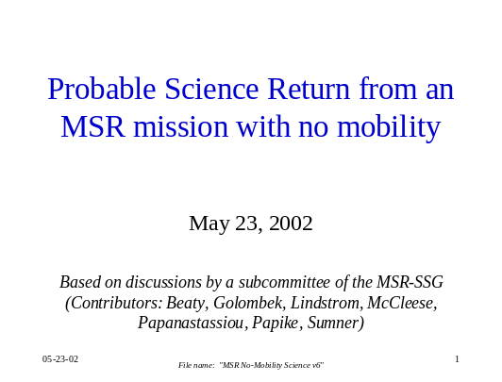
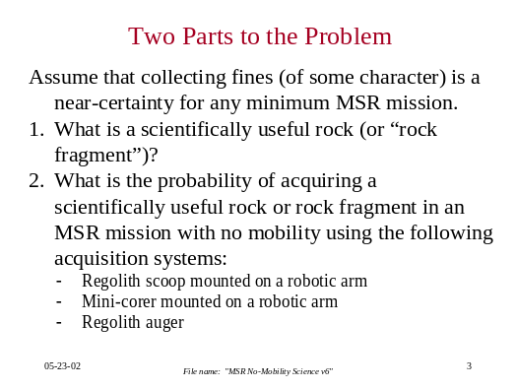
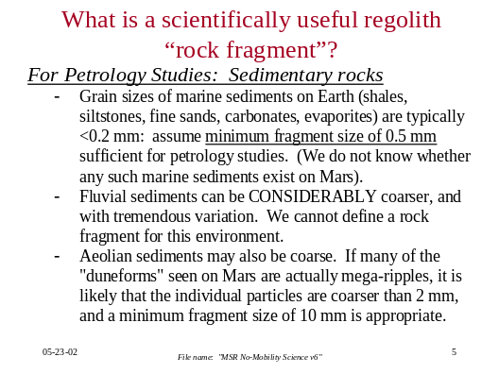
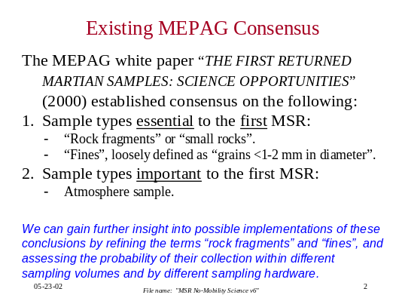
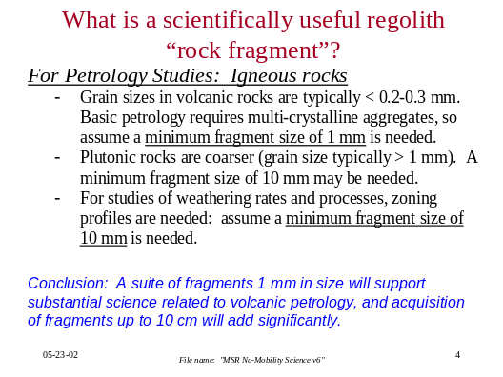
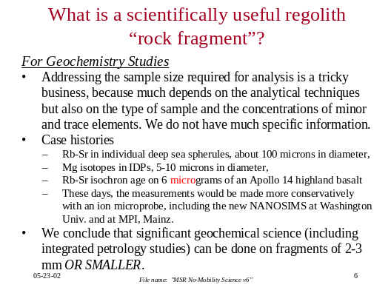
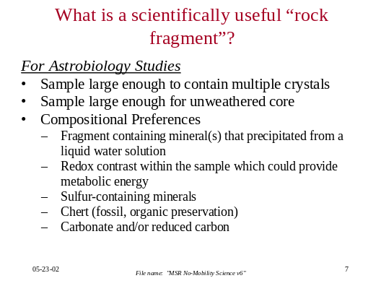
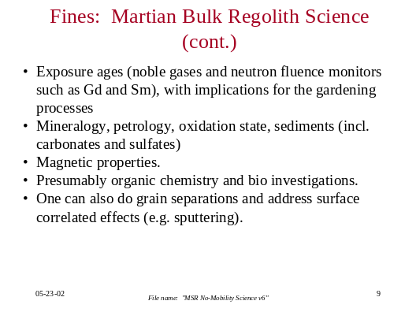
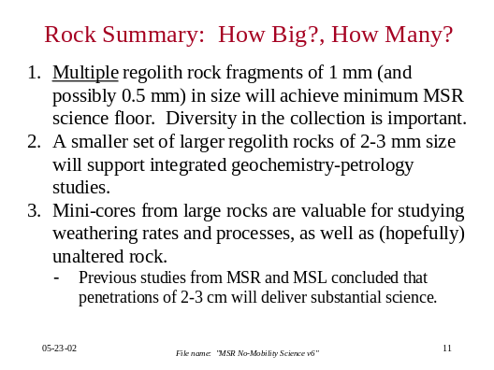
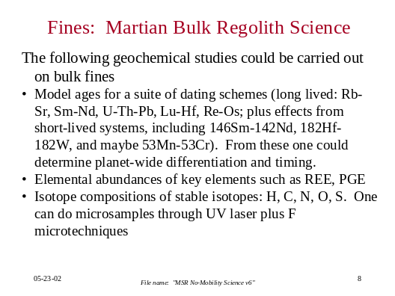
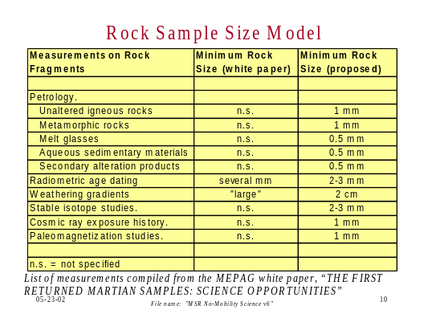
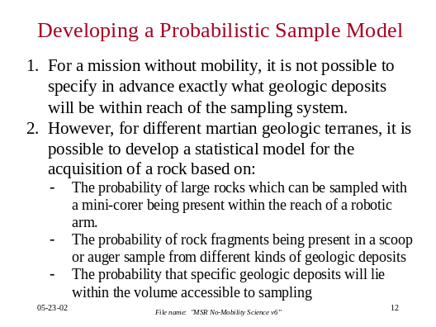
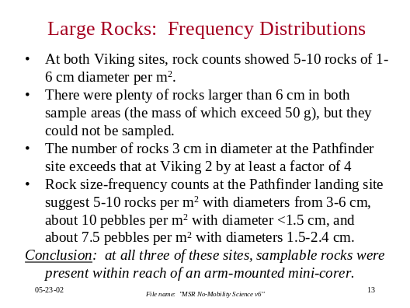
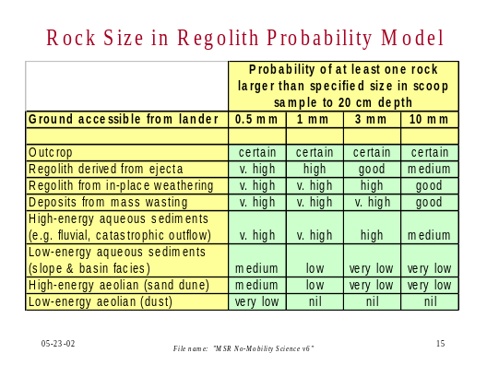
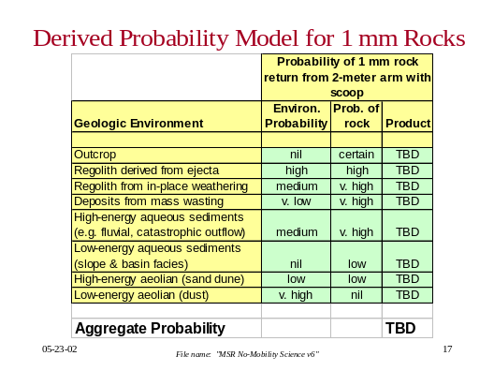
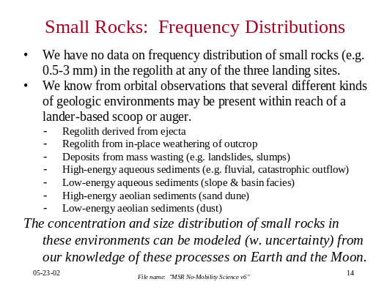
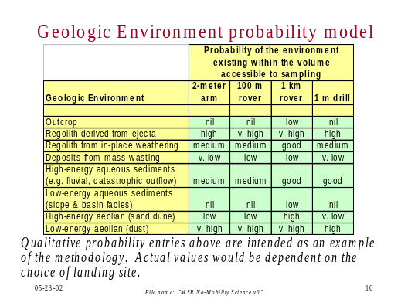
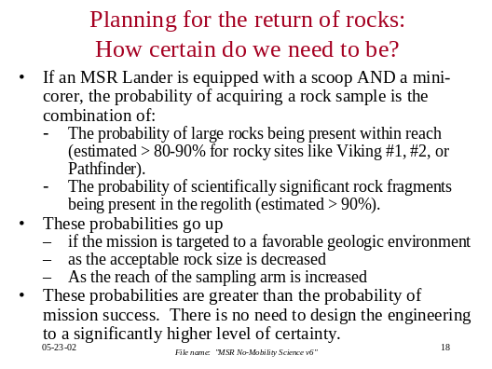
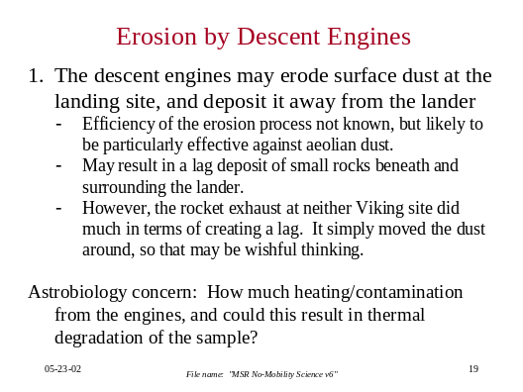
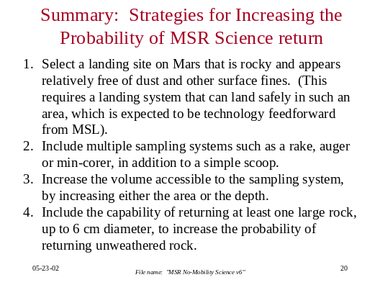

See Appendix A for a list of members and other participants

